# jCollege Programs of Study

Develop a small demo application which provides access to add, remove, and modify information of the program of study into the college program database.

## Mock-up screens

### Page 1 - List of Programs.

This page should contain a table with information on all the programs of study stored in the database.

List of Programs

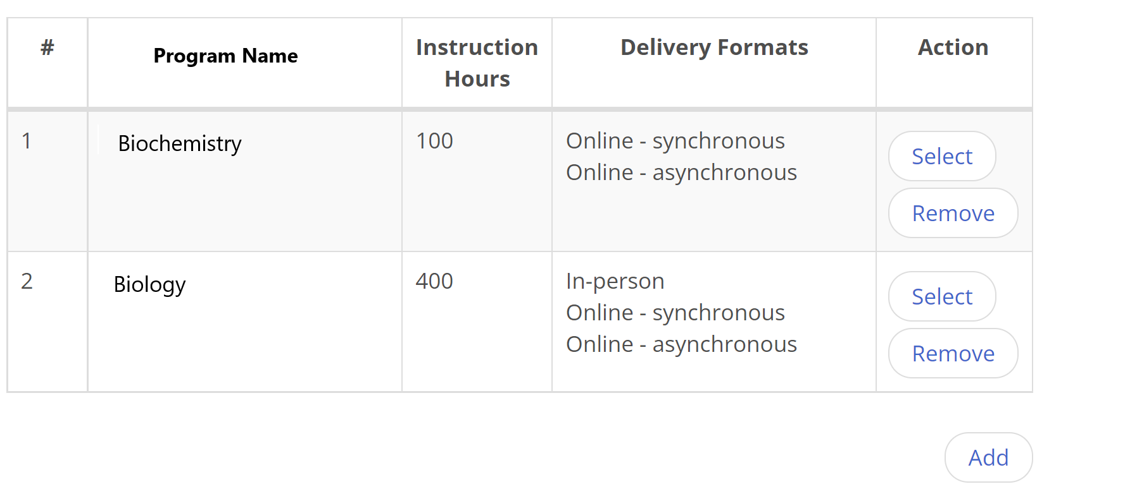

Business Rules

|  |  |
| --- | --- |
| 1 | Page Title – “List of Programs” |
| 2 | Show saved in the database list of programs in the “List of Programs” table |
| 3 | Page table columns:   * Item number * Program Name * Instruction Hours * Delivery Formats * Action |
| 4 | Action “Select” navigates to “Program Details” page, where the user can edit program information. |
| 5 | Action “Remove” will delete a program from the database |

### Page 2 - Program Details.

This page will allow users to input new program information or modify existing ones.

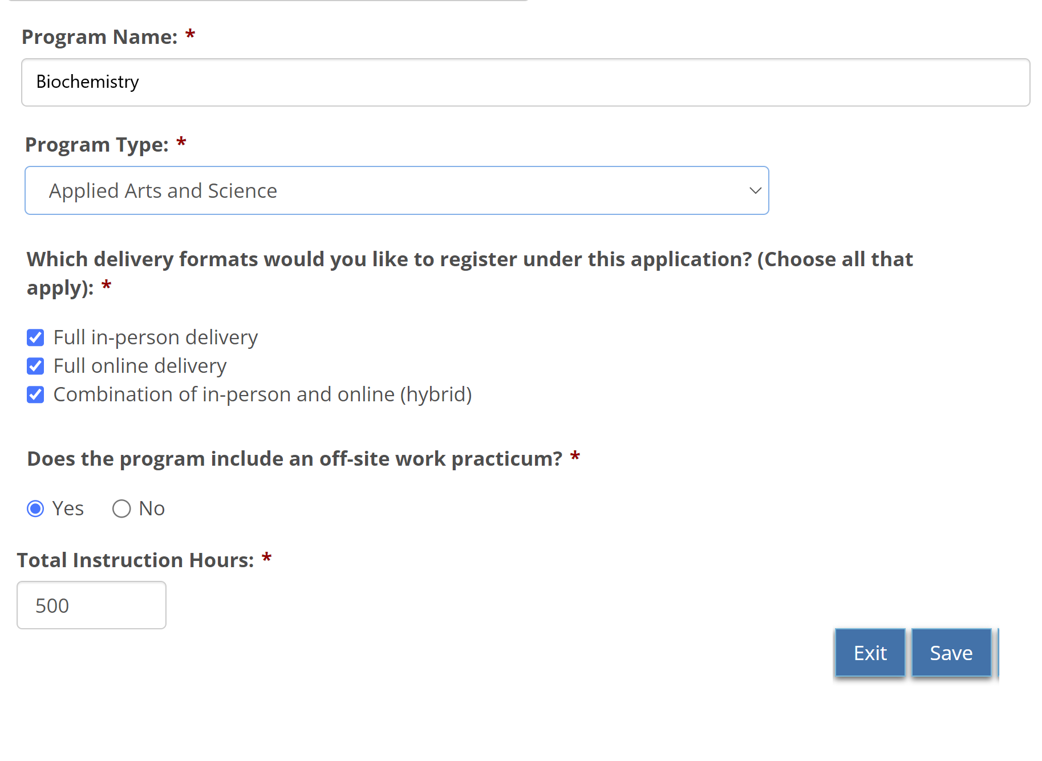

## Business Rules

### Fields:

|  |  |  |
| --- | --- | --- |
| N | Field | Rule Description |
| 1 | Program Name | * Field label: “Program Name” * Field type: alphanumeric - 200 * Validation: Mandatory on Save |
| 2 | Program Type | * Field label: “Program Type” * Field type: drop-down selection from the list:   + Applied Arts and Science   + Business   + Combined   + Community and Social Services   + Computer and Information Technology   + Construction Trade   + Flight Training   + Health Services   + Human Services   + Industrial Trade   + Law and Public Safety   + Motive Power Trade   + Service Trade   + Services   + Technical   + Technical Standards and Safety Authority (TSSA) Restricted Tradesperson   + Tractor-Trailer / Driver Licensing * Validation: Mandatory on Save |
| 3 | Delivery format | * Field label: “Which delivery formats would you like to register under this application? (Choose all that apply)” * Field type: multiple choice of:   + Full in-person delivery   + Full online delivery   + Combination of in-person and online (hybrid) * Validation: At least one delivery format must be selected on Save |
| 4 | Work Practicum | * Field label “Does the program include an off-site work practicum?” * Field type: radio-buttons Yes/No * Validation: Mandatory on Save |
| 5 | Instruction Hours | * Field label “Total Instruction Hours” * Field type: numeric * Validation: Mandatory on Save |

### Buttons

|  |  |  |
| --- | --- | --- |
| N | Button | Rule description |
| 6 | Exit | Functionality:   * Navigates to “List of Programs” page without data saving. |
| 7 | Save | Functionality:   * Validation: See “validation” for fields in Fields table * Persist data to the database. * No navigation from the page. |

## Implementation Plan

1. Database model design. Consider the persistence module structure:

* Table structure, you need to store all input data (fields, keys, constraints).
* If you need multiple tables, consider what type of relationship your data model will provide.

1. Application structure design (consider layered structure, what type of beans will be used, role and responsibility of application layers).
2. Front-end objects design and development (HTML, backing beans, navigation between pages).
3. Mid-tier layer (services, validation).
4. Back-end objects design and development (DAO, SQL queries).
5. Layer integration.
6. Application tests (unit tests, integration test, etc.).

## Tools and application frameworks to be used:

1. Java 1.8
2. JSF 2.2
3. HTML 5.0
4. Spring 4.x
5. MyBatis
6. IDE: Eclipse
7. Application Server: WebSphere 8.5
8. Database: Oracle
9. Oracle IDE: SQL Developer
10. Source control: SVN